Task 1: Create the File Using C++ and Write Two Lines

#include <iostream>
#include <fstream>
using namespace std;

int main()
{
// Create the file and write two lines
ofstream file("lab5.txt");

if (!file.is_open())
{
cout << "Error: Could not create lab5.txt" << endl;
return 1;
}

file << "This is the C++ file handling lab.\n";
file << "We are writing into a file using C++.\n";

file.close();

cout << "Task 1 completed: lab5.txt created and written successfully." << endl;

return 0;
}

Output:
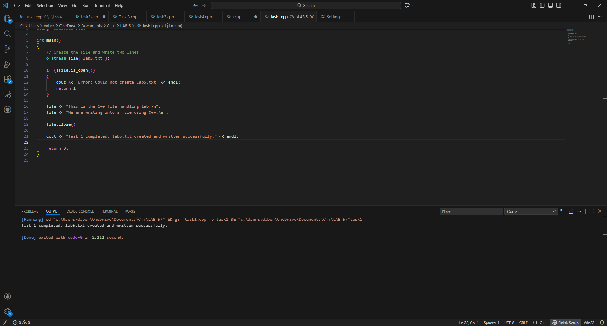

Task 2: Append a New Line into the Same File
#include <iostream>
#include <fstream>
using namespace std;

int main()
{

// Append mode (creates the file if missing)
ofstream file("lab5.txt", ios::app);

if (!file.is_open())
{
cout << "Error: Could not open lab5.txt" << endl;
return 1;
}

file << "We will perform several file handling operations.\n";

file.close();

cout << "Task 2 completed: New line appended to lab5.txt successfully." << endl;

return 0;
}

Output:
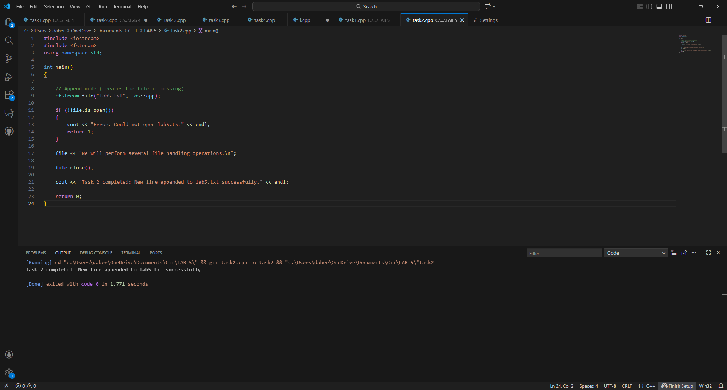

Task 3: Read the First Word from lab5.txt

#include <iostream>
#include <fstream>
using namespace std;

int main()
{

ifstream file("lab5.txt");
string word;

if (!file.is_open())
{
cout << "Error: Could not open lab5.txt" << endl;
return 1;
}

file >> word;

cout << "First word: " << word << endl;

file.close();
return 0;
}
Output:
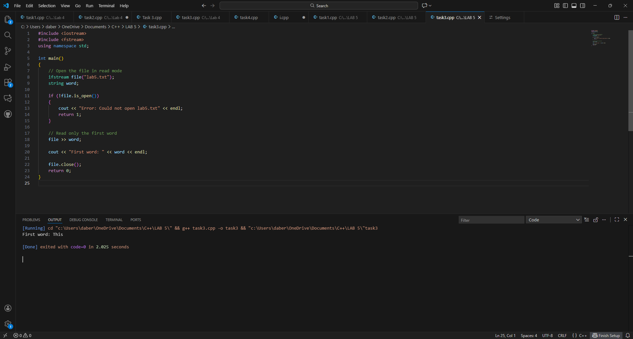

Task 4: Read the First Three Words
#include <iostream>
#include <fstream>
using namespace std;

int main()
{
// Open the file
ifstream file("lab5.txt");

if (!file.is_open())
{
cout << "Error: Could not open lab5.txt" << endl;
return 1;
}

// Variables to store the first 3 words
string w1, w2, w3;

// Read the first three words
file >> w1 >> w2 >> w3;

// Display them
cout << "Word 1: " << w1 << endl;
cout << "Word 2: " << w2 << endl;
cout << "Word 3: " << w3 << endl;

file.close();
return 0;
}

Output:
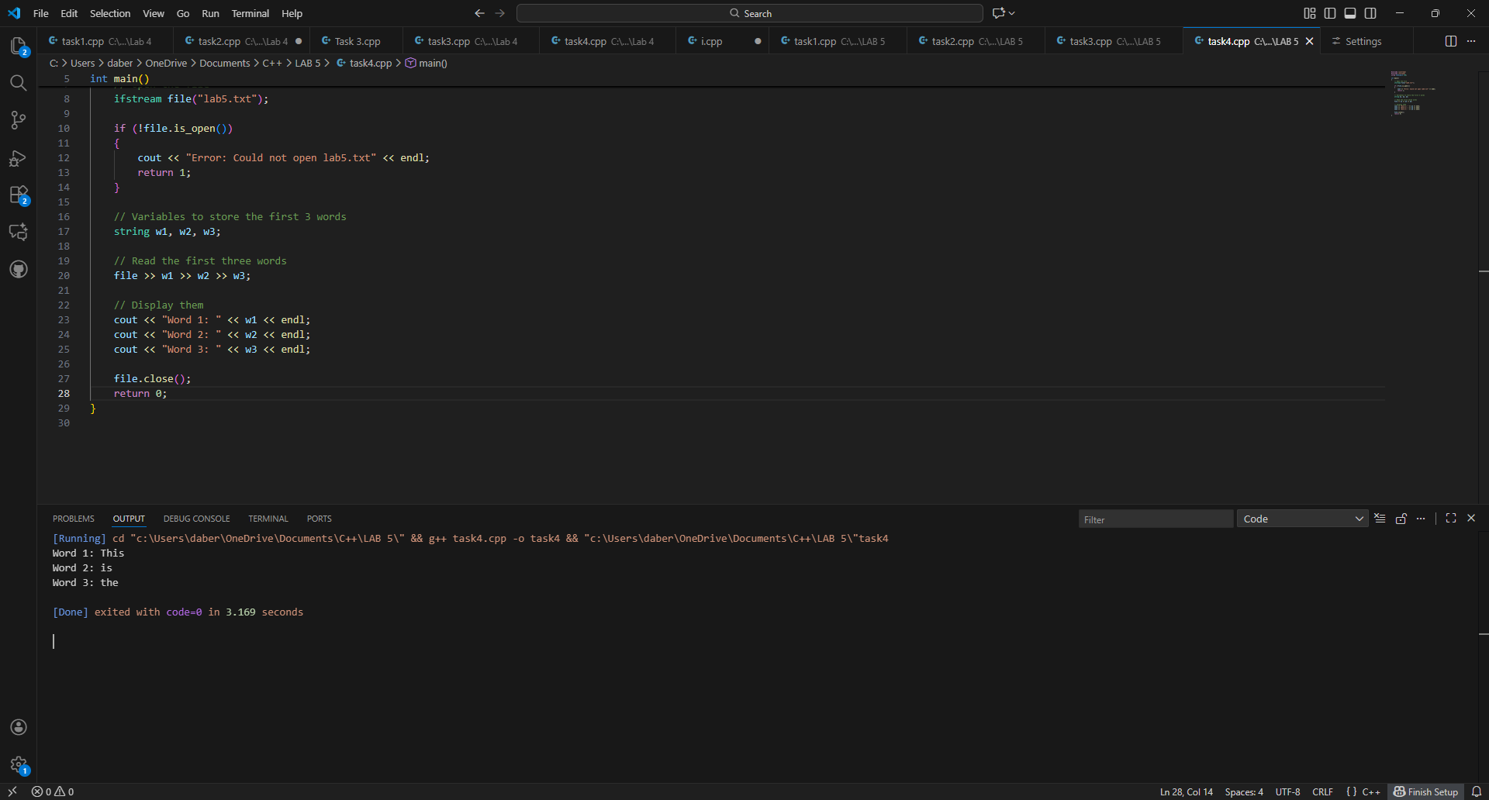

Task 5: Read the First Full Line
#include <iostream>
#include <fstream>
#include <string>
using namespace std;

int main()
{
ifstream file("lab5.txt");
string line;

if (!file.is_open())
{
cout << "Error: Could not open lab5.txt" << endl;
return 1;
}

// Read the entire first line
getline(file, line);

// Print the line
cout << "Line: " << line << endl;

file.close();
return 0;
}

Output:
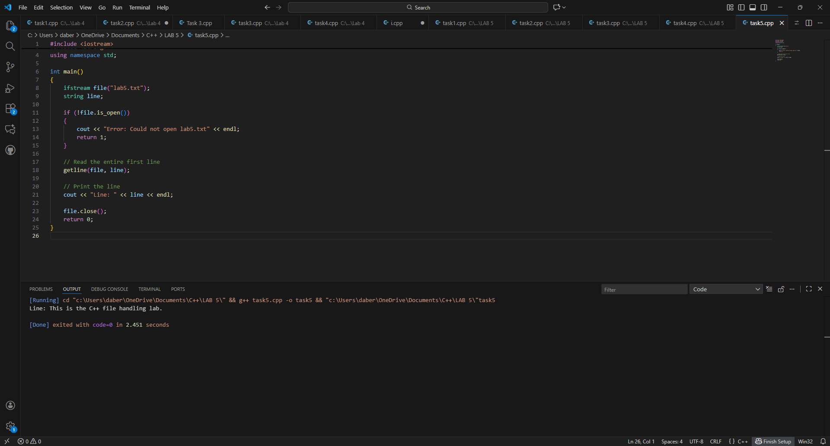

Task 6: Read the Entire File Line-by-Line

#include <iostream>
#include <fstream>
#include <string>
using namespace std;

int main()
{
ifstream file("lab5.txt");
string line;
int count = 1;

if (!file.is_open())
{
cout << "Error: Could not open lab5.txt" << endl;
return 1;
}

// Read and print all lines with line numbers
while (getline(file, line))
{
cout << "Line " << count << ": " << line << endl;
count++;
}

file.close();
return 0;
}

Output:
